**Financial & Customer Insights Dashboard**

**Overview:** The "Financial Performance and Customer Insights Dashboard" provides a comprehensive overview of key financial and customer-related metrics. This dashboard presents data on revenue, loans, customer demographics, churn reasons, fraud detection, and risk assessment to help stakeholders make informed decisions.

**Key Performance Indicators (KPIs):**

* **Total Customers:** 15
* **Total Revenue:** 383K
* **Active Loans:** 12
* **Average Customer Satisfaction:** 3.73
* **Total Return on Investment (ROI):** 221K
* **Total Loan Issued:** 366K

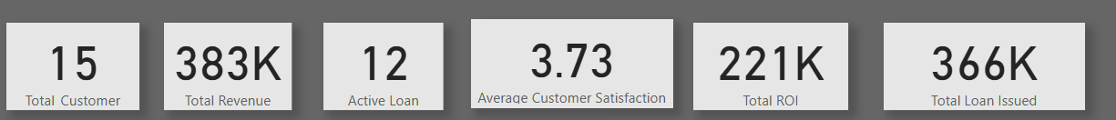

**Dashboard Insights:**

**Revenue and Loan Performance**

* **Total Revenue by Region:**
  + South: 0.14M
  + East: 0.09M
  + West: 0.08M
  + North: 0.08M

* **Loan Types Distribution:**
  + Home Loans: 55%
  + Auto Loans: 28%
  + Personal Loans: 17%

* **Loan Amount Trends:**
  + The sum of Loan Amount by Customer ID and by Month shows distribution across different clients and periods.

**Customer Demographics & Churn Analysis**

* **Customer Segmentation:**
  + Retail: 67%
  + Corporate: 33%

* **Churn Analysis:**
  + Major churn reasons include "Better Competitor" and "High Fees".
  + Churn observed across different quarters and months.

**Financial Risk and Fraud Detection**

* **High-Risk Customers:** Identified as 4 customers.
* **Fraud Detection:**
  + Investigation statuses include "Under Investigation" and "Investigation Complete".
  + Fraud Flags are monitored by Customer ID.
* **Risk Assessment:**
  + Credit Score and Default Probability tracked for financial risk evaluation.

**Investment & ROI Insights**

* **ROI by Investment Type:**
  + Stocks: 0.60M
  + Bonds: 0.50M
  + Mutual Funds: 0.50M

* **Sum of Account Balance Trends:**
  + Tracked across different years and months.

**Customer Support & Feedback**

* **Resolution Time for Support Logs:** Tracked per ticket.
* **Customer Satisfaction Rating:**
  + Averages and distribution of feedback received.

**Marketing & Sales Performance**

* **Marketing Campaign Performance:**
  + Budget, Conversion Rate, and Leads Generated monitored.
* **Regional Sales Performance:**
  + New customers acquired, revenue growth, and total sales tracked.

**Data Model Structure:** The dashboard is powered by multiple interconnected data sources, including:

* Loan Portfolio
* Credit Card Transactions
* Savings Accounts
* Investment Portfolios
* Customer Churn
* Customer Demographics
* Fraud Detection
* Risk Assessment
* Expense Management
* Employee Performance
* Regional Sales Performance
* Marketing Campaigns
* Customer Support Logs
* Customer Feedback

**Conclusion:** This dashboard serves as a critical tool for monitoring financial performance, customer behavior, and risk factors. It enables decision-makers to analyze trends, identify potential issues, and optimize business strategies. By leveraging these insights, businesses can enhance customer retention, mitigate financial risks, and improve overall performance.